Ex no:2a Creating a VM and adding storage ,memory, and network to a VM
Date:20-07-2026

Aim:
To create a Virtual Machine (VM and configure its memory, storage, and network settings for installing and running an operating system.
Procedure:

Step 1: Open Oracle VM VirtualBox
- Launch Oracle VM VirtualBox Manager.
- Click the New button.

Step 2: Create a New Virtual Machine
- Enter the Name of the VM .
- Select the Folder where the VM will be stored.
- Choose the Type .
- Select the Version
- Move the slider or enter the RAM size.
- Click use an existing virtual hard disk. Click Next Dynamically allocated → Click Next Set disk size (e.g., 20 GB)
- Click Next.
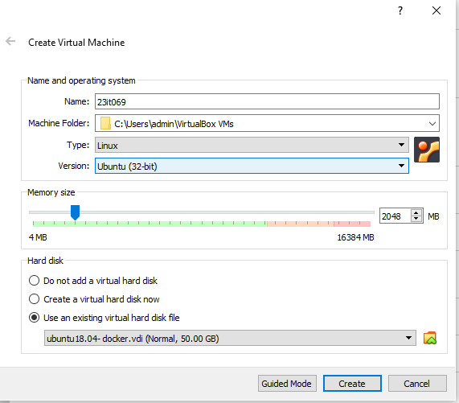
Step 3:
Configure Network Adapter Go to Settings → Network Ensure Adapter 1 is: Enabled Attached to:Bridged Adapter (for internet + LAN access), or Host-Only Adapter (for communication with host only) Click OK Then new vm has been created
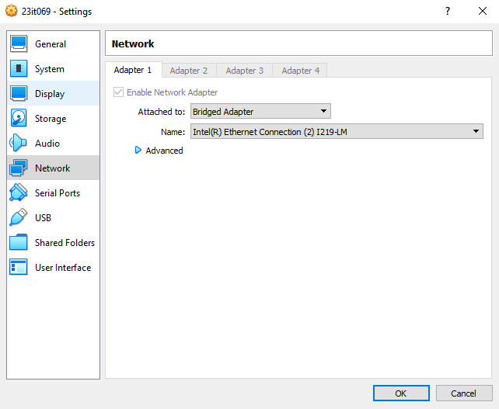
Execution of java program to test the execution time between vm (Ubunttu) and host(Windows)
1)To find the sum of digits between 1 to max of long datatype
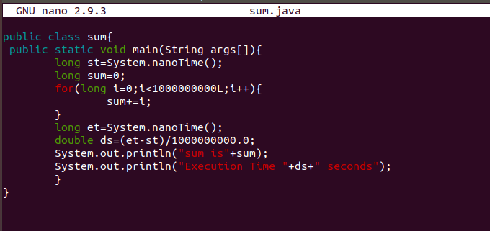

Execution time in Linux:
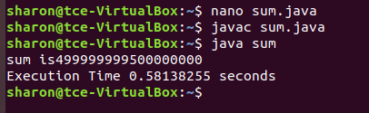
Execution time in Windows:
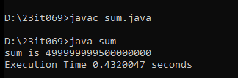

From the above the execution time in linux is 0.5813 s where the time taken by the windows is 0.432 this clearly tells that the windows host is faster than the linux VM.

Result:
Thus the Creation of VM and adding Storage, Memory, and Network to a VM has been created successfully and output has been verified.

